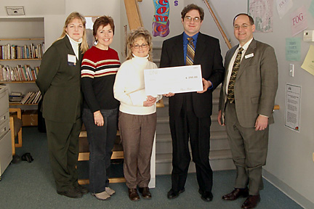

FOR IMMEDIATE RELEASE
Contact: Renee Fellows
603.434.9433
Rfellows@oneclearpoint.com

BNI Londonderry Group Pledges Support to The Upper Room
Networking Group Reaches out to the Community with Financial Support and Volunteerism

Londonderry, NH (January 14, 2004) – A check for $250 was presented to The Upper Room, a family resource center, today by Business Networking International’s Londonderry Referral Group Chapter. While this may not seem like a large contribution, the group also pledged ongoing financial and volunteer support to The Upper Room in an ongoing effort to extend their reach into the community.

“We’re making a statement,” says Londonderry Chapter President Steve Brown, “Not only do we enjoy doing business in Derry and Londonderry, but we’re here to be of service to our community. We are continually seeking out new members. By being active in our community and supporting non profit organizations that provide such tremendous services to our neighbors, we’re providing another selling point when prospective members visit our chapter and consider joining us.”

The Londonderry BNI group also promised ongoing support through monthly donations of diapers and baby wipes as well as volunteers from the group to help out whenever possible. “It’s wonderful to offer up a check,” says Londonderry Chapter Treasurer Steve Feinberg, CPA “but it’s much more meaningful that we will continue to provide assistance monthly and through individual time and efforts. We feel like we’re making a long-term connection and a difference.”

The Upper Room is a non-profit family resource center located in Derry that serves the Southern New Hampshire region. Offering individual and group counseling, anger management sessions, classes on a litany of family topics, and referrals to outside resources, the organization is committed to strengthening individuals, families and the community.

“We’re very fortunate to have such wonderful donors and partners,” says Kimberly Bavaro, Executive Director for the Upper Room. “Every contribution we receive is another service we can provide, another person or family we can help. Our budgets are determined by such acts of community activism and we’re so grateful for groups like BNI and their ongoing sponsorship.”

For more information on Business Networking International’s Londonderry Referral Group contact Steve Brown at 603-560-3535. To learn more about The Upper Room please contact Kimberly Bavaro, Executive Director at 603-437-8477 or visit the web site at www.urteachers.org.

About BNI
Business Networking International is the world’s largest business networking and referral organization. With chapters nationally and internationally, BNI has over 52,000 members and provides over $856 million in referrals to its members. For information on the New Hampshire BNI Network, contact Mike Roberts, Executive Director at 603-893-5893 or visit the web site at www.bninh.com

About The Upper Room
The Upper Room is a family resource and outreach center serving the Greater Southern New Hampshire community. A non-profit organization committed to creating educational programs and services which strengthen individuals, families and the community, The Upper Room provides all its services free of charge with no restrictions to income guidelines or geographic boundaries. For information on programs and services contact Kimberly Bavaro, Executive Director at 603.437.8477 or visit the Web site at www.URTeachers.org.

